**SYD502**

**Assessment 1**

Blake Gillanders

01/08/2023

Contents

Page 1… Title page.

Page 2 … Contents page.

Page 3 …. Requirement elicitations techniques, purpose of the technique and start of interview with webstore owner.

Pages 3 to page 6 … Interview with webstore owner.

page 6 to page 8… Project managers decisions.

Page 8 … Summary for this section.

Page 9 … Research by analysis of suitable websites, purpose of this technique, analysis of 2 websites, start of mighty ape pages.

Pages 10 to page 12 … Mighty ape pages continued.

Pages 12 to 15 … Paper plus.

Page 15 to page 16 … Summary page for this section.

Page 16 … Observation of systems, Discuss the purpose of this technique start.

Page 17 … Discuss the purpose of this technique continued, video walkthrough of mighty ape.

Page 18 … video walkthrough of mighty ape.

Page 18 to page 20 … summary page for this section.

Page 20 … Interviewing, discuss the purpose of this technique, interviews.

Page 21 … Interview 1.

Page 22 … interview 2.

Page 22 to page 23 … Summary page for this section.

Page 23 … questionnaires and surveys, discuss the purpose of this technique, My survey page start.

Page 24 … my survey continued.

Page 25 to page 30 … Summary pages for this section

Page 30 … Part B LO2: Users and their Needs, Discuss the different types of system requirements start.

Page 31 … Discuss the different types of system requirements continued, Discuss the different types of system users as discussed in class.

Page 32 … 3 different groups of users and their requirements.

Page 33 … Case diagram

Page 33 to 34 … Business profile

Page 35 … references

**Part A: Requirement Elicitations Techniques**

**Analysis of documents.**

1. **Discuss the purpose of this technique:**

the purpose of this technique is to analyze the answers that both the webstore owner and project manager has given to the questions and any details about how their operation works so and what requirements they need for their system to function properly so we can then extract any relevant information and work out how we can design our system to meet all their needs

**B. Produce and analysis of the information gained from both the interview and the project managers decisions**

**Interview with web store owner**

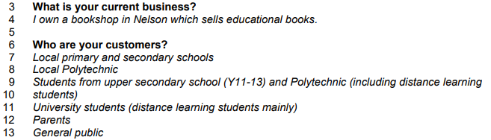

On lines 3-13 the webstore owner tells us that the webstore is a book shop that’s main product is selling educational books to mostly students for any year level ranging from primary school to university. They also sell books to the public and parents so there needs to be different sections in the system to separate educational books by school year level, subject, and purpose whether it is for studies or general education.

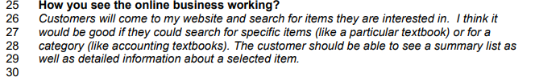

So, the webstore owner states here that the system needs to include a search feature that can search for textbooks by name or by category they webstore owner also requires to have a summary list and a detail section where details about the book can be written once the customer has clicked onto a certain item.

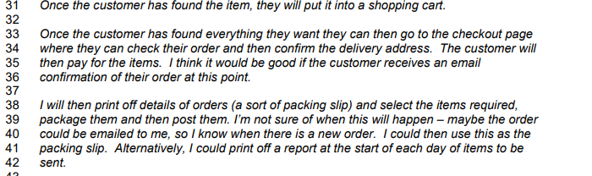

There also needs to be a shopping cart where the customer can put all the items, they are going to buy into then that needs to lead to a checkout page that should be easy to use for the customer and have multiple forms of payment for easy use. After customers complete the checkout process and pay for their order the system needs to send out an email to the customer confirming their order and thanking them for purchasing through the store and include any relevant information related to shipping or contacting the store. The webstore owner also would like to receive a different email when an order is placed with details about what items they selected so it can be used as a packing slip. During the checkout process there also needs to be a tick box where customers can choose if they would like to receive emails with special promotions. And a follow-up email with all the relevant tracking information. The webstore owner requested those 2 features on lines 48-50



They also need an effortless way to update their current sales and inventory systems they have said they are unsure if they want automatically updated every time and order is placed or posted or even at the end of each business day personally, I believe the best option is to automatically update the system every time and order is confirmed.



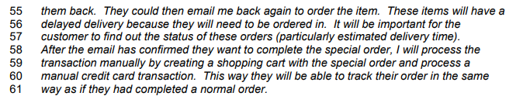

Customers need to have a way to special order items that the webstore does not have in stock the webstore owner says the customer needs a way to email them with details so either a link to a composed email would work but it would be quite basic so a contact form could be included on the website for special orders. The customer needs to also be kept informed about the delivery times of the item once it has been located so after the customers item is located the webstore owner wants to be able to manually add a special-order item to the system and charge the customer for it so they can then order it and send the customer the eta delivery times through the confirmation email.

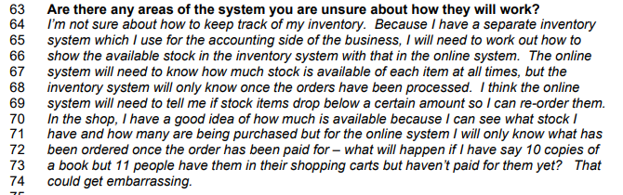

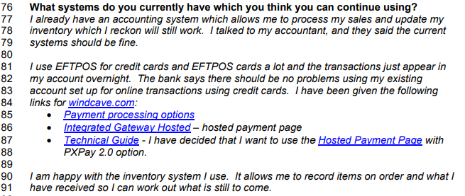

The webstore owner has a separate inventory system that is also used for accounting they have requested to keep that system as its easy for them to used and store their information so we will either need to link their accounting system to the webstore or make one with similar functionality, so it is easy to use. They also want to keep using the same bank account for transactions and they already have some research done into their payment processing options and have decided that they want to use the hosted payment page with PXPAY 2.0 option which accepts visa and Mastercard, but they have opted out of using pay pal and after pay for the time being.

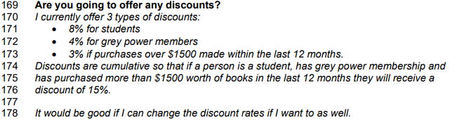

There needs to be a verification system to prove that the customer falls under any of these categories so they can get any of the discounts listed. The webstore owner also wants to be able to add/remove or adjust discount rates

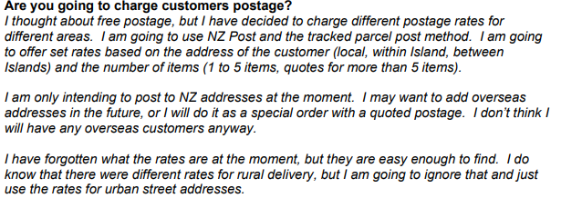

So there needs to be a list of postage rates at the checkout that are automatically calculated due to the physical size and weight of their order it also needs to consider whether the customer is local, overseas (North or South Island not international), rural, or urban and base the shipping rates on those details and the current NZ Post rates.

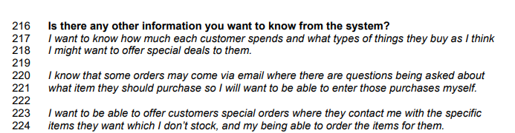

The systems database needs to include how much each customer spends on each order as well as what items they have bought and their names so their total order amount can be tracked to see if they meet the discount requirements.

**Project managers decisions.**

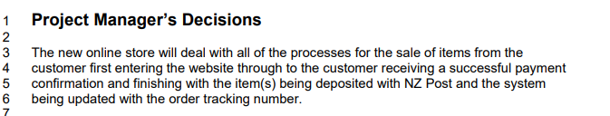

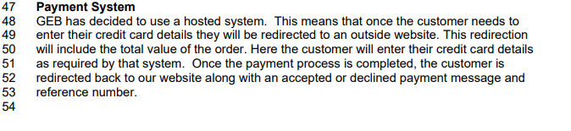

So, the project manager has mostly decided to stick with the webstore owners' decisions so the website will function with the same search filtering and category method the webstore owner described, and items will also be uploaded with a full description as requested as well as having a similar check out system as described earlier the payment system will also remain the same in lines 58-59 the project manager discussed that they want to also use the hosted system so the customer enters their payment details they're redirected to and outside website which has all the payment information and that the customer confirms then they will be redirected back to the new website where if the payment goes through an email will be sent out with confirmation details and references and tracking information.

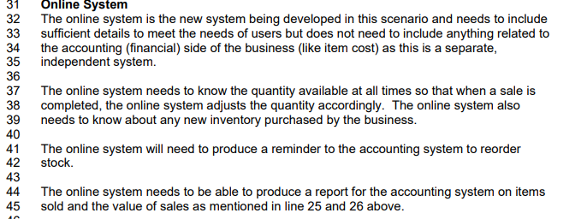

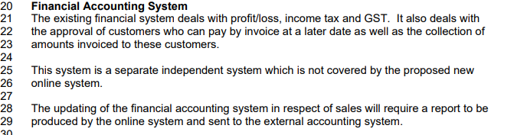

So the online systems needs to hold specific information to meet the user requirements like the amount of stock on every item, prices, current sales and any other information that’s relevant to the customers it also needs to be able to produce reports of the sales to be sent through to the current accounting system which is separate to the new online system that the project manager has decided to keep using.

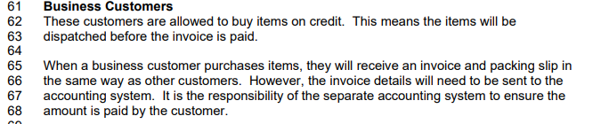

So the project manager has decided to continue to allow business customers pay through credit which means items get dispatched before payment is received so the online system needs to receive and invoice when the items are purchased but aren't required to pay it straight away some sort of account system would work where the business can preload credit onto their account after confirming their identity. The invoice details of each purchase will need to be sent to the separate accounting system to ensure the amount is paid by the customer, so it is not the responsibility of the new online system to ensure payments are made by business customers.

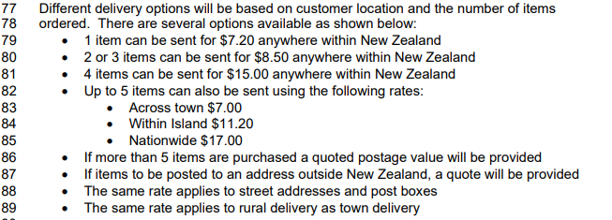

The project manager has decided to use NZ post as their only delivery service using the cheapest options for parcel postage. They need to be able to send items nationwide and potentially internationally. Postage prices are dependent on the customer's location and number of items ordered. They have decided on a fixed rate for postage which means 1 item can be posted anywhere nationwide for $7.20,2-3 items can be sent for $8.50 nationwide, 4 items nationwide can be sent for $15.00 and 5 items can be sent with the following rates; across town for $7.00, within the same island for $11.20 or nationwide for $17.00. If more than 5 items are purchased a quoted price from NZpost will apply. This also applies to international deliveries and the same rates listed above apply to any street addresses, Po boxes or rural addresses.

**Summary**

In summary the webstore owner produced some great ideas for the online webstore like the search filtering feature which will include having a search bar that searches for either a specific item(book) that the customer wants to find, or it will be able to search for a category of books e.g. the subject of the book (history, math, class textbooks... or the purpose of the book like weather it's for general education or a class related book and after the desired book it's found there needs to be a summary list and a detailed description below the book explaining its contents there also needs to be a stock number for the book so customers cant order it if it's out of stock this will be a useful feature in the final design for navigation. After the customer has found what they want to purchase their needs an easy to use check out system which will include a shopping cart where customers can add items, they would like to purchase then continue onto the checkout page where they have the options to pay via master card or visa through the hosted payment page or to pay through credit if they have a business account setup with the online store. After items are purchased, the website needs to produce a report that gets sent to the customer with payment confirmation and information about tracking. The webstore also needs to produce a report for the business, so they have a packing slip for the parcel and have data on what has been sold. There is also going to be a full list of postage prices listed on the website. These prices and price categories can be found on the notes listed above.

**Research by Analysis of suitable Websites**

1. **Discuss the purpose of this technique.**

The purpose of this technique is to Analyse two different websites to see what features they include to make the whole online shopping experience easy to use and navigate and to see what features are commonly being used across multiple websites so we can also implement those features into the final design. It also allows us to know how to implement the features the webstore owner and project manager has requested because it shows us how those features work, what they include and why they work.

1. **Produce an analysis of 2 suitable ecommerce websites using annotated screen shots. (Screenshots are located below the paragraphs)**

Website 1: [Mightyape](https://www.mightyape.co.nz)

As soon as you enter Mighty ape's webstore, you're greeted with a vibrant front page that has whole range of their best-selling products that are in different categories depending on what they I think this is a good sales strategy because it shows items that you weren't necessarily looking for in a really appealing way and makes your mind wander a little bit and encourages you to look for items that you weren't originally looking for I think this is something that should be added into the final design. On the front page they also have their current promotions, which is a fantastic way to advertise their promotions and create more sales. On the image below I have 3 arrows. The top arrow is pointing to their best-selling items and the two bottom arrows are pointing to their current promotions. 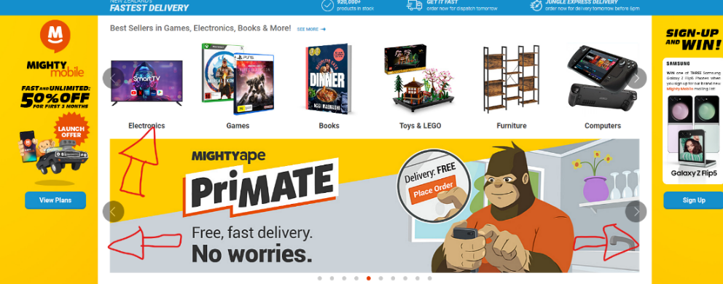

Next at the top of the page you will notice the navigation bar that has a shopping trolley icon (image below text) which is a feature that will be implemented into the final design so when you find an item you want you can add it to the trolley just like you would in a supermarket so when you go to checkout you have all the items you want to purchase saved in the trolley. You can also click onto the trolley icon to see what you have and remove items from the trolley like you would in real life. Also on the navigation bar is a really obvious easy to use search bar so this search bar allows you to search any keywords for the item you want and it will display items based on those keywords it also has a drop down that shows recommended search results based on what your typing in and you will notice there also another drop down that you can click on and press the category of the item you are looking for.

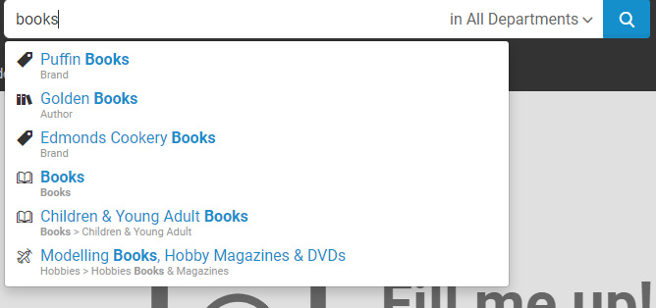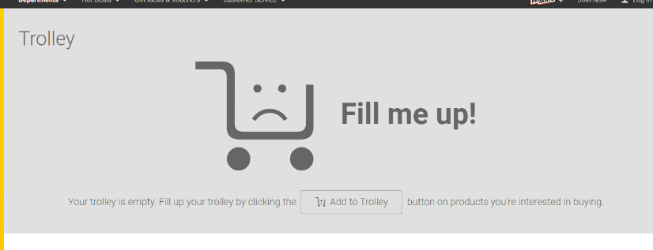

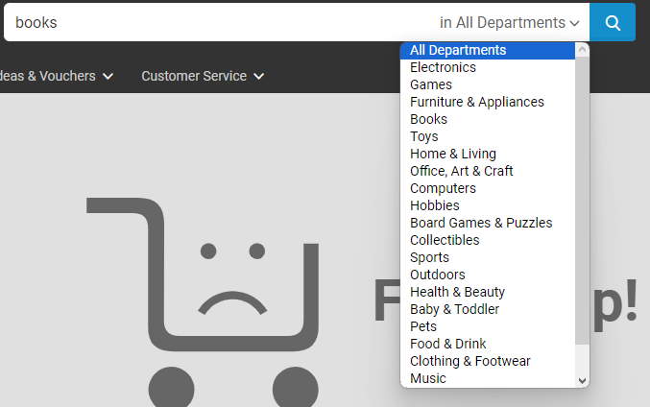

Mighty ape also has a contact page that can be found in the footer section of the page after clicking on it you can select the reason for contacting them then it will display a contact form where you can fill in your details and how they will contact you and then write your message and request special items or write a general request/complaint

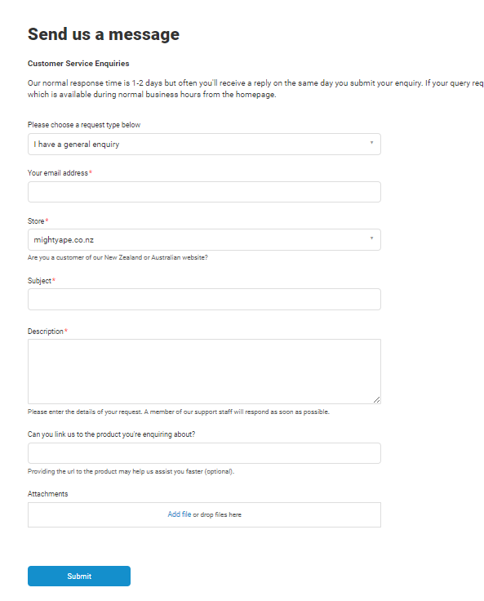

Next up when you click on an item you want there's a title at the top of the page and usually multiple photos of the item so you can see what it looks like and below there's also a full description on the item that describes what it's about who it's made by and what it's for this gives useful information to the customer and is also a feature that will be implemented into the final design.

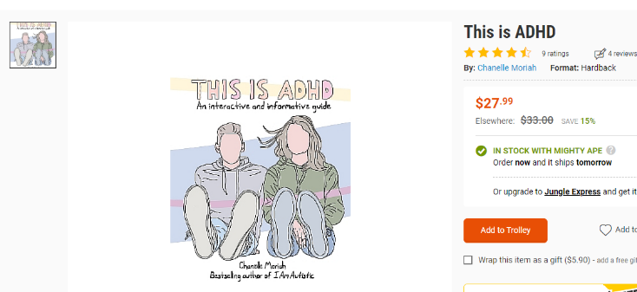

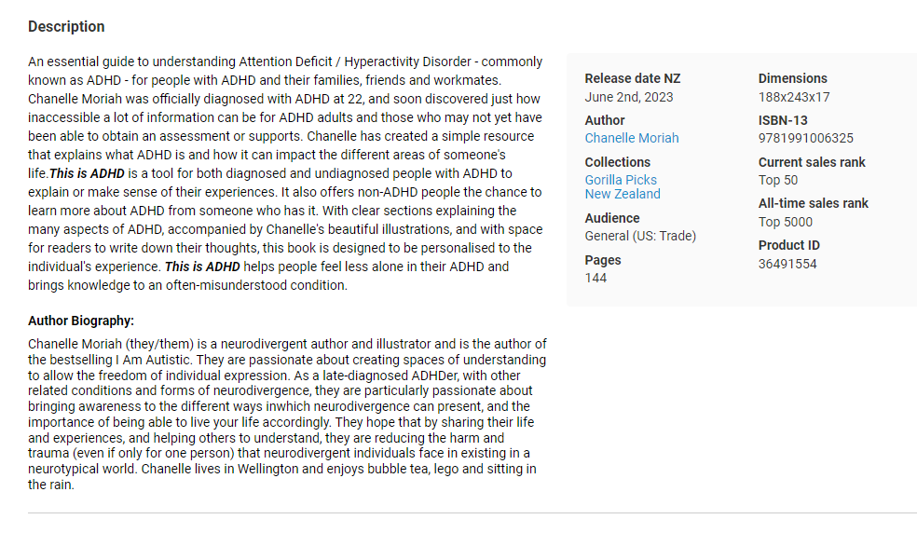

When you go to the checkout page the first thing your prompted with is to either log in or create an account which would be a useful feature for business’s who are looking to purchase on credit or a way for customers to make the checkout process easier there is also a second option to purchase as a guest.

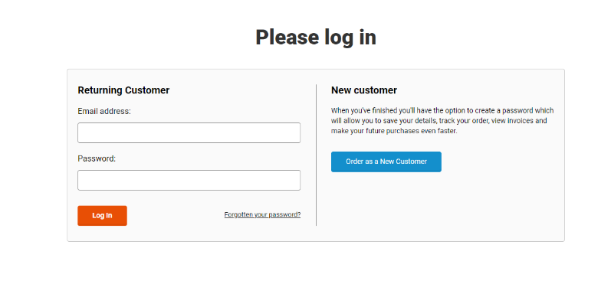

The next page is a form where you enter all your deliver details such as your name address, email address for contact and a delivery address this is useful for identifying who the package is for and where it is going to be delivered

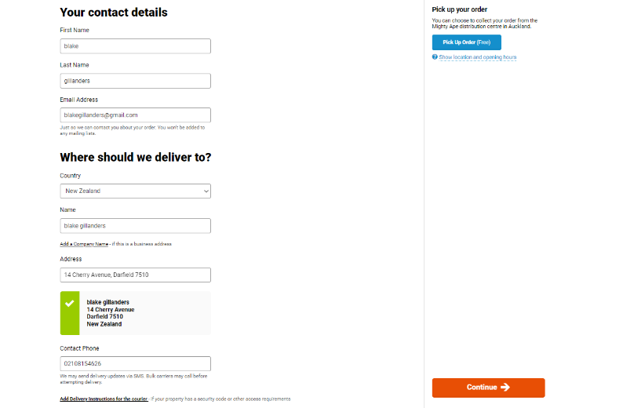

After completing the contact details form you go to the payments page where they give you a quote for delivery to your selected address and your order total. They also include all their payment methods on this page in the and after you select one, you are prompted with a form where you can fill in all your payment details to pay for your order and shipping. After paying the website automatically sends you a confirmation order and will later send you an email with the parcel shipping information and a tracking number. There is also a link that you can click to enter a promotional code which will apply a discount based on the selected promotion and alter your final payment amount.

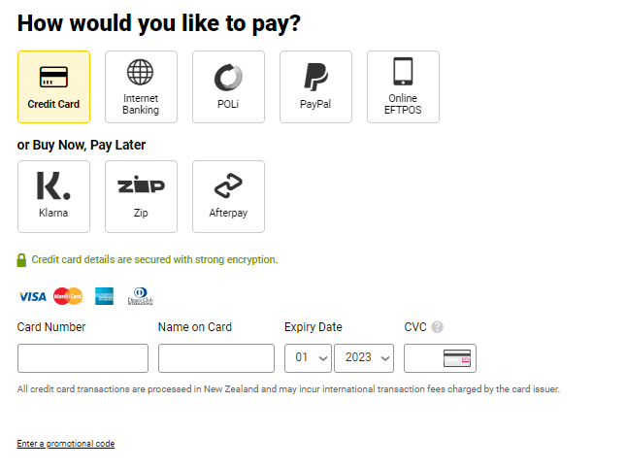

**Website #2:** [**Paperplus**](https://www.paperplus.co.nz/?gclid=Cj0KCQjw0bunBhD9ARIsAAZl0E2l22yWXP9Ah8I9YGUTVDeeFPk_q6PV7sV_a13OvTfL3TVIzZ1Vnu0aAmzLEALw_wcB)

The next website we will be looking at is paper plus. Paper plus is an online bookstore that also sells school supplies and stationery. When you access their online webstore your prompted with a similar design while it looks aesthetically different the basic functions work the same and are in similar areas which proves how good the website design is because two different very popular well performing websites use this design. So first, when you enter the website, you will notice the navigation bar includes a search box where you can search for items based on keywords or categories and when you type something in a drop down will appear with recommendations based on what you’ve type. On the right side of the search box there is also a clickable drop box where you can select a category of item you are looking for and search within that category. Besides the search bar there is also a trolley button that leads you to your shopping cart which has all the items you have selected and wish to purchase just like what you would do in a real-life store, which makes purchasing items quite easy.



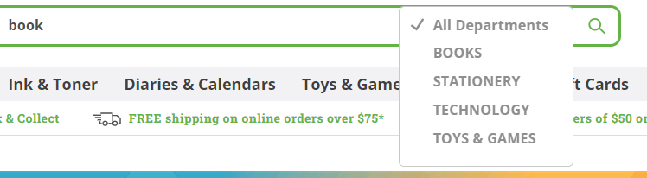

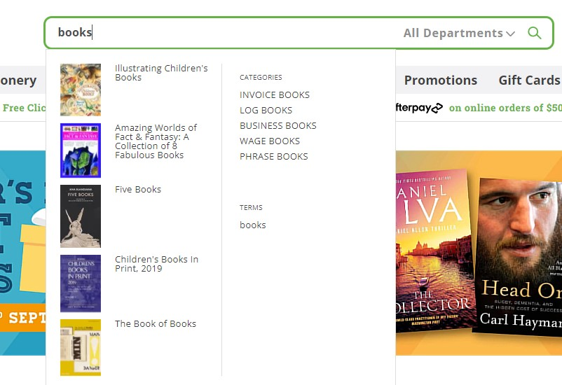

Once you have selected an item you like your redirected to the items page where there's a photo of the item Aswell as a brief description that is less detailed than Mighty ape but still has some important details about the book on the page you also have the title/name of the item and a button to add it to your cart over all this page is a nice design but mighty apes design is better due to more detail in the descriptions.

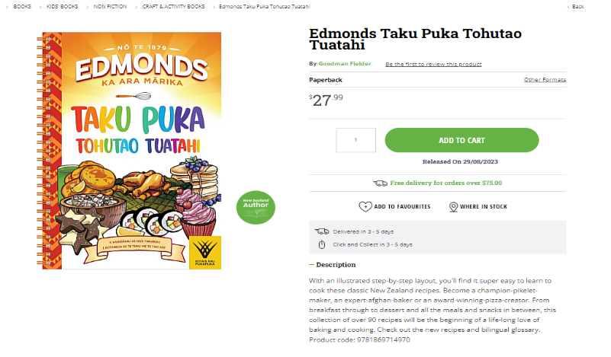

If you cannot find the item you want or have problems with the online webstore, they also have a contact page that can be found at the top of the screen above the navigation bar. Once you open the contact page, they have their store locations on google maps is well as their contact information for you to contact them

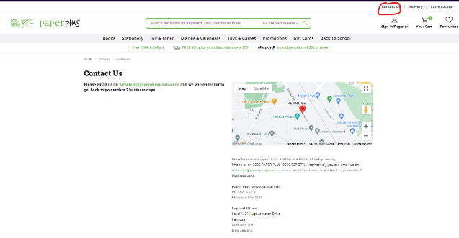

Next up paper plus has the same process for payment there is a page you can either log into an account which once again would be useful for business’s purchasing through credit or customers logging in with their saved details to make the checkout process easier but there is also a checkout as a guest button for new customers who do not want to make an account

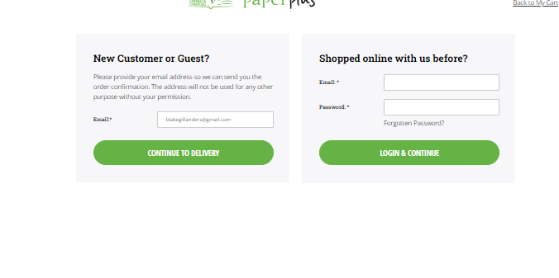

After selecting continue as a guest your prompted with a form to fill in with your personal details for example your first and last name contact information such as your phone number and email address and a delivery address which allows them to deliver the parcel to you and provide you with a delivery estimate

.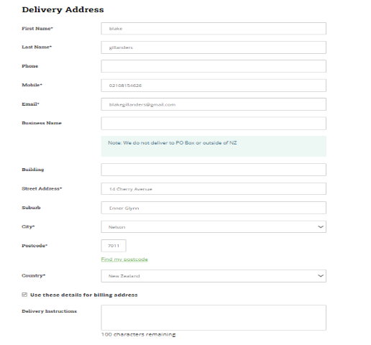

The next stage of the checkout process is the payments page where you have a list of all their accepted payment methods. When you select one it redirects you to a page where you can enter all the required payment details in a secure manner. After placing your order paper plus sends you a confirmation email with details of your order and an order confirmation which is later followed up by tracking information

from their selected courier.

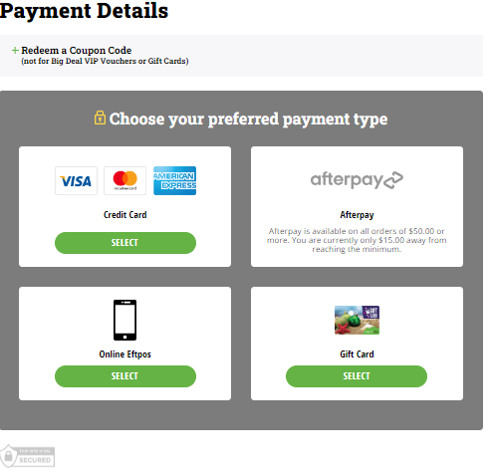

**Summary of my findings**

So, to summarize what I found when looked through the key features of both websites I found that both mighty ape and paper plus have similar functional designs on the home page both websites have their top selling products to encourage customers browse through items they were not necessarily looking for. They also both promote all their special deals and promotions in very vibrant ways to encourage customers to purchase items that are on special. When it comes to functionality, they are both similar. The search bar has a drop down that appears when you half type text in to show you recommended products based on what you are typing. You can also enter key words into the search box and search for results related to those key words or type in a specific item and it will direct you to that item. There is also a clickable drop down menu that allows you to search for items or keywords within a specific category to narrow down your search results. And after you’ve searched for the item, you're looking for you can click on the selected item, and it redirects you to a products page that includes a picture of the item, a title for the item/name of the item and a description of the item I found that mighty ape generally has better more detailed descriptions on the items which I think is better than paper plus's shorter descriptions. Next step on both pages you can add items to your shopping trolley like you would in real life so if you are buying multiple items, they are right there at the checkout page. Both websites do this in a really similar easy to use way and after you have filled up your shopping trolley with all the items you want the checkout process is very straightforward you can either log into an existing account or create a new one this feature is useful for business clients so they can purchase through credit or returning customers to make the checkout process easier. There is also another option for new customers to checkout as a guest, so they do not have to go through the account creation process. After this step you’re redirected to a form that you fill out with your personal details such as your name address and contact information so the website can log that information for shipping details and ensure your parcel/s gets delivered to the correct address these forms are really straightforward to use and don’t ask for unnecessary information which is really appealing to customers. After filling out your details you are directed to the payments page which is secure and has a list of different payment options that you can use and once you have selected the one you want you can fill in your payment information to complete the order. Upon completing the order, you are emailed a confirmation email with information about the product’s order and when the item is shipping, you are sent an email with shipping/tracking information. Both websites also have a contact feature paper plus’s feature is easier to find but has less features as it just shows the location of stores and a link to their email address whilst mighty ape offers a more user-friendly contact form which I think is a much better option for the online webstore. Overall, these two websites are very similar in design and implement these features in a useful way and I believe after seeing how these features such as the search system, item descriptions and the payment system work the webstore owner would want to implement these systems but I for the contact page I would take notes from paper plus and make it easier to find but then use the design from the mighty ape webstore with a full contact form as its easier for the customer to use.

**Observation of systems**

**Discuss the purpose of this technique.**

The purpose of the technique “observation of systems” is to observe how 2 or more different user groups interact with the selected system which in this case is the ecommerce website called “mighty ape”. So, I am getting a new customer who is also not very tech savvy (my fiancé Pallas) to make a video recording of her browsing for an item that she has selected. After she finds the item, she must add it to cart and check out so we will be able to observe how easy or difficult she finds this process. We will be comparing this to a video of me Blake, a much more tech savvy person and someone who has used the website in the past to purchase items. I will look for the same item as her, add it to cart and proceed to checkout and compare the 2 videos to see how different it is for us to use the website and how easy/difficult it was.

**Video walkthroughs of the mighty ape website**

**NEW Customer (my fiancé Pallas)**

Here is a quick video walkthrough from the point of view of a new customer my fiancé Pallas who has never used the website mighty ape before here is the LINK: [Mighty ape NEW customer](https://www.youtube.com/watch?v=v32jZig-6Qs)

[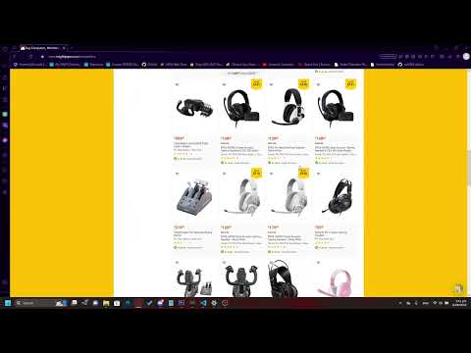](https://www.youtube.com/watch?v=v32jZig-6Qs)

**RETURNING Customer (Me Blake)**

Here is an even quicker walkthrough of the website mighty ape its filmed from my point of view as a returning customer So the difference between this and the last walkthrough is I have a lot more experience on this website as I have spent countless dollars on mighty ape and ordered too many items. Here is the link to the video: [Mighty ape returning customer](https://www.youtube.com/watch?v=yNZaW3l63sI)

[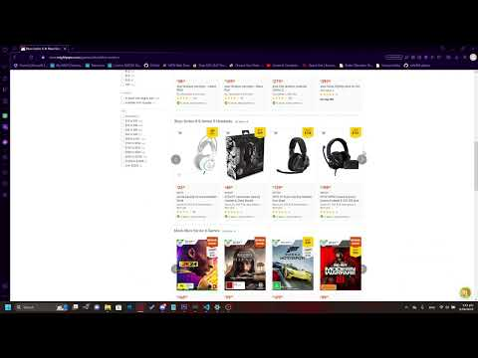](https://www.youtube.com/watch?v=yNZaW3l63sI)

**Summary**

So, to start off the summary I am going to be talking about the first video which I had my fiancé Pallas record before that moment she had never been onto mighty apes' website so did not have a good understanding of how the website works. But although she was a new user it only took her 1 minute and 20 seconds to locate the item she was looking for and add it to cart. As you can see when she first opens the mighty ape website, she has a little look through the front pages and gets distracted by the promotions section and then decides there is nothing interesting there. She then does something interesting and clicks on the “computers” category to search for the item “Xbox series x” which wouldn’t be under that category, but I can understand why a new user would get confused by that in the video the “computers category” has a picture of a steam deck as the thumbnail which looks like a gaming console and could definitely cause some confusion for new users so I think the thumbnail pictures on the categories need to be more clear about what it contains this is something that I will take into account for the final design on the website. Once she’s in the computers category she searches for “Xbox” to locate the gaming console and after no related results she searches for “Xbox series x” to be more specific about what item she's looking for and as a new user she can't identify that the search bar is set to the “computers” category but when she searches the keywords into the search bar it has a drop down that identifies what item she's looking for and that it's in a different category but as a new user she doesn’t realize that’s what the website is telling her and searches for her keywords and is confused when the item doesn’t show up. I think this is something else that should be implemented into the final design if the web system can identify the item that the user is searching for it should redirect them to that item regardless of what category they are searching in it would make it a lot easier for new users.

After a few seconds she realizes here mistake and presses the “remove all filters” button thinking that would fix her problem as it is the most obvious button, she can see but all it does is clear her search results and redirect her to the computers category home page. I think by pressing “remove all filters” it should clear both the selected category and the search results it would make the entire process easier on new users. After being redirected back to the computer's category home page she realizes her mistake and removes the category filter and searches for her item. Once she finds it, she simply adds it to the trolley and proceeds to checkout. As a new user she has a clear and easy to use form where she can enter her details and have the item delivered.

Next up we will be looking at my video walk through of the ape website. So, my video walkthrough differs from hers as I am a returning customer to the mighty ape website, while I was living with my parents and had no bills, I purchased more items through this website than I can count so my walkthrough was a lot clearer and more precise as I have a great understanding on how this website works. So, to make this walkthrough easy to compare to the previous walkthrough I searched for the same item my fiancé chose which was an “Xbox series x” and instead of trying to find the item manually through the category system I chose to search for the item in the search bar at the top of the page and had no problem finding it. This is an example of a Very easy system to use for experienced users all I had to do was search for the keywords and I found my item within seconds. It is crucial for the final design to have this level of ease when it comes to users shopping through the website. Next up after I found my item, I clicked on it and pressed “add to trolley” after adding to trolley I went back onto the website and decided to look for a game to go with it, so I backed out of the products page and searched through the “Xbox series X games” category and found a game I liked and simply added it to trolley with the Xbox. From there I pressed the checkout button and was automatically signed into my account as I am a returning user. This has all my personal information saved such as name, address, phone number and email address but not my banking details. This makes it even more efficient for returning users to shop through their website and is something I intend to add to the final design.

Both walkthroughs provided useful information about the accessibility of the website they showed me that while the design of mighty ape is good for tech savvy users/returning customers it has some small flaws when it comes to new customers for example when my fiancé was browsing through the mighty ape website she got confused searching for a specific item that wasn’t in the category she selected. A way this can be improved for the final design is to redirect the customer to the item they have searched for if their system recognizes it even if it is not in the category they have selected. We also got some useful insight into the differences between returning customers and new customers at the checkout new customers had to fill out a form with all their personal information which was really easy to understand and fill in so that’s something that I want to implement into the final design but returning customers had it a lot easier with all of their details saved to an account they have created. That is another feature that needs to be added to the final design.

**Interviewing**

**Discuss the purpose of this technique**

So, the purpose of this technique is to interview 2 different people to determine what features they find useful on an online webstore. An interview in person will allow me to explain my questions better than other methods of gathering information and will in turn allow me to get more useful information.

**Interviews**

So, my interviews are both uploaded below this text in the form of a YouTube video and the questions I asked both interviewees are as follows

* Have you ever purchased anything online and if your answer is yes how frequently would you say you purchase items online? (open question)
* Do you find online shopping easier than in-store shopping? answer with yes or no (closed question)
* Why do you think online shopping is easier for the consumer than going to a physical store? (probing question)
* Have you ever found an online store that was too hard or confusing to use? And if yes, why was it so difficult to use?
* The final question I have for you is have you ever decided not to use a website based on the lack of features or design? If so, what features was that web site missing?

**Interview #1**

**I**n this first interview I am interviewing my mum, Brooke.

[**Interview #1**](https://youtu.be/jNYSEK9YyEk)

[](https://youtu.be/jNYSEK9YyEk)

**Interview #2**

**In the second interview I am interviewing my dad, Scott.**

[**interview#2**](https://www.youtube.com/watch?v=2VvlarOwZmY)

[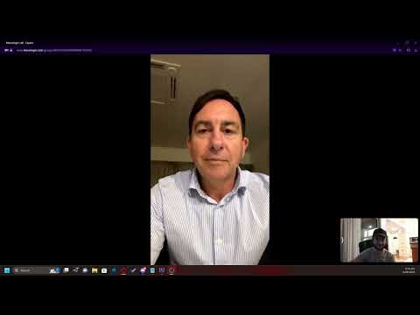](https://www.youtube.com/watch?v=2VvlarOwZmY)

**Summary**

From Interview 1 with my mother, I found that some users aren’t frequent online shoppers, so it takes them longer to learn how to use an online webstore, so this reinforces the fact that the layout and design portion of the website probably the most important part of the system design to encourage customers to return. She also said that she has found websites that she’s found difficult to use in the past and its mostly related to the search feature on the website like she's had difficulty trying to find an item that she knows is on the website due to an overcomplicated search feature so this mean the functional features of the website need to be easy to use and have a self-explanatory design. In Interview number 2 I interviewed my dad who is a more frequent online shopper. He mentions that online shopping is better for customers due to the ease of access and wide selection of items online as well as the ability to research items. So, this means for the customers a wide range of items is important as well as detailed descriptions and a review feature on each item this allows the customer to research the item better to ensure it’s the item they’re looking for. The next thing my dad mentions is some websites have a “clunky” or hard to use sign up system so this means the sign-up form or sign in process needs to be as easy and smooth as possible for the customers with clear instructions to encourage them to return to the website. He also mentions that websites with a good returns system are better to use this relates to the contact feature on the website so an easy to find and easy to use contact form is essential for customers on the website.

**Questionnaires and surveys**

**Discuss the purpose of this technique**

So, the purpose of doing surveys/questionnaires is to gather responses from potential customers who do a lot of online shopping to see what features on a website they find useful to make the whole experience as easy and enjoyable as possible. It also gives us a good idea of what features they use the most on the website so we can make those as prominent and easy as possible.

**My survey: link** [**to survey**](https://docs.google.com/forms/d/1gZXP-WKRVnFrvkQdb2lOMdkI46OnxyqcNf9XnUTTo5E/edit)

For my survey I made a 10-question survey called “online webstore requirements” I tried to make it as easy for users to complete so I decided to include only 10 questions so I could get 10 complete responses. The first question on my survey was titled “When you look for a specific item on an online webstore do you browse using a search bar or do you browse through different categories to find the item you're looking for.” the question is a closed question where you can either answer yes or no created this question to determine how users browse for items they want and weather it's through search options or browsing through categories to find the item they're looking for this helps me determine whether I should make the search bar or a list of categories the prominent feature for navigating the website. The second question I implemented is titled “what feature/s do you find the most useful when purchasing items on a webstore.” and the survey users could respond with a short answer in their own words this will help me gather intel on what features they users find the most useful when it comes to online shopping and will help me determine what features to implement into the final design. Next up the 3rd question I decided to add to the survey is titled” when purchasing an item online do you find it useful to have multiple pictures of the item?” users had the option to answer with 3 different responses “yes, no or sometimes” this question here helps me determine how much information I should put into the pages for each item. Next up the 4th question titled “if a website is poorly designed and hard to navigate but offers better prices on a selected item than another website which is very easy to use which website are you more likely to use.” which has 2 different responses either “website with lower prices” or “website with better design” I found this to be a really interesting and useful question because it helps me determine if webstore users prefer to have an easier and more enjoyable website vs better prices on really poorly designed website and helps me think more into the level of detail and useability the website needs to meet the users requirements. The 5th question on my survey is titled “have you ever left a review on a website” I made this question out of curiosity to find out how often the reviews feature is used on a website and how important it is to implement it into the final design. The 6th question I have created for the survey is titled “are promotions/sales an important factor that you take into account when choosing what website, you will purchase an item from” this question has 3 different answers to it “yes, no or maybe” or is probably my Favorite question on the survey because it gives me useful information on how important promotions and sales are to users on online webstores which the results from this question can also help me determine how important it is to advertise these promotions both on the website and outside of the website and the frequency on which promotions should be available. So, the 7th question that I have included on the survey is “on a scale of 1-10 how likely are you to return to a website if they offer an easy to navigate store and fair prices” which is a question that includes a 1-10 scale for users respond with 1 being not likely and 10 being very likely this helps me determine how important a well-designed store that’s easy to navigate is to webstore users and how much of a factor prices are into their final design about whether they're going to purchase an item or not. The 8th question titled “have you ever used the contact page on a website before to request a special item that the store doesn't stock.” is a simple yes or no question based off an answer the webstore owner gave on line 53 of the “interview with the webstore owner” transcript I made this question to see how useful a feature that the webstore owner has requested will be to the webstore users. While the results of this question will not affect the decision to implement this feature into the final design it gives me some insight into how useful and important this feature is to average users. The 9th question on the survey is titled “what payment options do you generally use when purchasing an item online “and is a multiple-choice question where the survey users have 5 different options to choose from “Eftpos, Credit card, Afterpay or similar, Store credit or PayPal” users can choose 1 or more options from this question and it helps me determine what payment features are the most useful for webstore users and will help me determine what payment features customers would want to be included into the final design. The 10th and final question on the survey is titled “do you often leave reviews on items on websites” this question is a simple yes or no question and is similar to question 5 on this survey but is aimed to get different results. The aim of this question is to determine if users/customers often use the review feature on webstores to review a specific item this tells me how important this feature is on the website and gives me insight on if I should incorporate this feature into the final design.

**Summary**

**(pictures below the text)**

My goal with this survey was to make a nice and brief survey that was easy for users to complete but would also provide me with valuable information. So, I chose to add 10 questions to my survey with easy to understand and answer questions. This allowed me to get 10 responses to my survey from friends and family the first of which was titled “When you look for a specific item on an online webstore do you browse using a search bar or do you browse through different categories to find the item you're looking for.” All 10 users responded too and gave me similar and predictable results. Out of all 10 responses 9/10 or 90% of people stated that they browse for items through the search feature which allowed me to determine that it is more important to promote the search feature on the website and make it as easy to use as possible.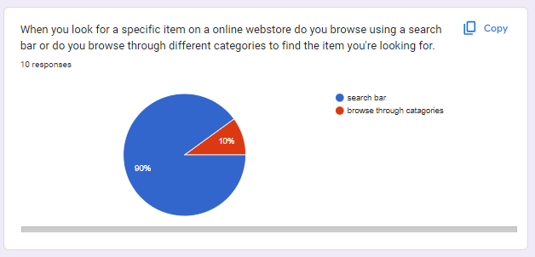

The second question was titled “what feature/s do you find the most useful when purchasing items on a webstore.” and allowed me to get a much bigger range of data it showed that 2 users find the most useful feature on an online webstore to be the description feature on a products page. This feature tells the customer more about what the product is a describes how it can be used and what it looks like. Next one user typed in the “sort feature (high to low)” was the most useful feature on a webstore this allows customers to display the items based on the price of the item from low to high and allows the customers to narrow down their search results based on price. Next, I had 3 users respond with “reviews” this is a feature that allows customers to place reviews on the products about the quality of the item and that they then post to the webstore so other customers can read them and base their decision to purchase on those reviews. The final response I received on this question was about the “search feature” which is one I predicted would be the most popular because it allows users to quickly locate an item they are looking for. Overall, I think all these features that the survey users selected should be implemented into the final design. 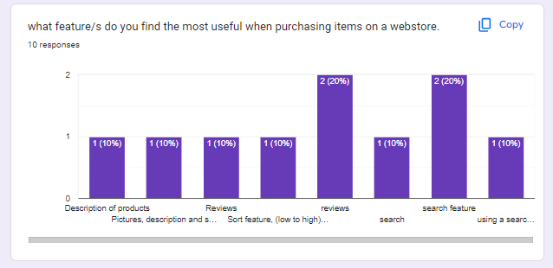

The third question on my survey is called “when purchasing an item online do you find it useful to have multiple pictures of the item?” This simple question helped me determine the importance of having pictures of each item is to the user. The results show that 7 or 70% of the Reponses say “yes” meaning that they believe having multiple pictures of an item useful to them when making a purchase and the other 3 or 30% of responses say “sometimes” which tells me that this feature is useful, but it is not essential to have multiple pictures of the item on the product page. I think based on these findings most items in the final design should have multiple pictures of the item to highlight all the features of the product.

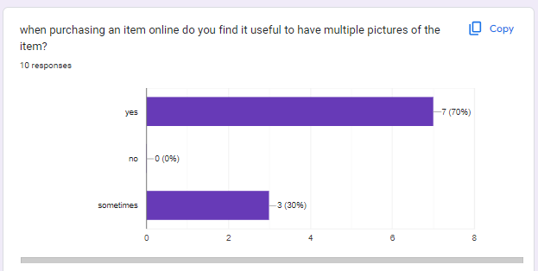

The 4th question on the survey is quite a unique question its titled “if a website is poorly designed and hard to navigate but offers better prices on a selected item than another website which is very easy to use which website are you more likely to use.” and it determines the priorities of customers whether they prefer an easy to use website that can make the whole experience easy for them or whether they would prefer a poorly designed website that’s hard to navigate but offers lower prices. 80% of the responses chose that a website that is easier to use and better designed is more appealing to them than lower prices meaning that the design of a website is an incredibly important feature to customers as they would choose an easier experience over literal savings.

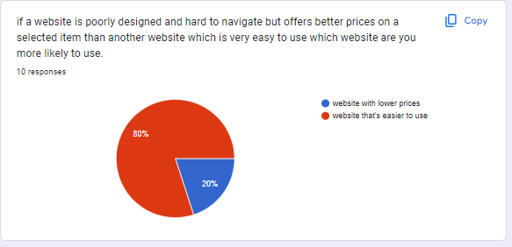

This next question divided the users a lot more. Its titled “have you ever left a review on a website” and it asks the users if they have ever used the review feature on the website. These results helped me decide how useful this feature is. 60% of users responded with “yes” which shows me that although everyone does not use the review feature it is still a particularly important feature for the final design as it helps customers decide on what product they want to purchase.

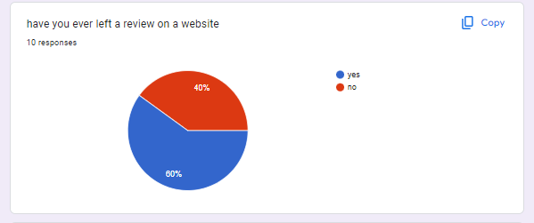

Question number 6 is titled “are promotions/sales an important factor that you take into account when choosing what website, you will purchase an item from “which determines the importance of promotions and sales for the customers 40% of users responded with maybe and 60% responded with yes which shows me that promotions and sales are very important to customers and should displayed well on the website like they were on mighty ape as it helps customers to decide to purchase through your website.

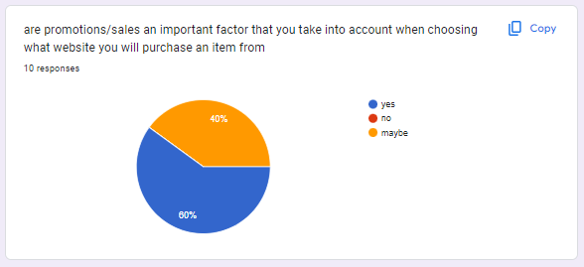

The 4th to last question or 7th question on the survey is titled “on a scale of 1-10 how likely are you to return to a website if they offer an easy to navigate store and fair prices” 90% of the responses were ranging from 7-10 which means the users are very likely to return to the website if it offers a combination of a good easy to navigate layout and fair prices this further confirms the results we got from question number 4.

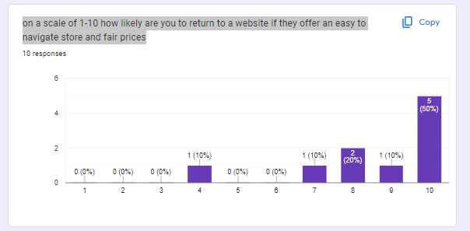

The 8th question on the survey was called “have you ever used the contact page on a website before to request a special item that the store doesn't stock.” which relates to a feature that both the webstore owner and project manager requested is implemented into the final design I decided to ask users how often they use this feature or if they have ever used this feature. From my results I determined that 80% of users said no but 20% said yes. This shows this feature is not very popular but because it is only really meant for a specific user group, I still think it will play a significant role in the final design.

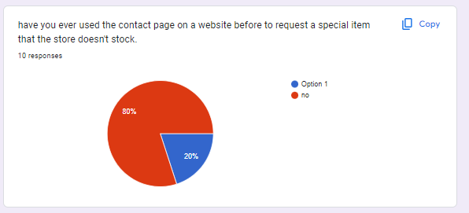

The second to last question was called “what payment options do you generally use when purchasing an item online” which had 5 different responses to choose from Credit card had 8 responses which shows us that this is the most common payment option and needs to be implemented into the final design. The second most popular option was Eftpos which has 6 responses. This also shows that it is a very important payment option to implement into the final design. Next up Afterpay or similar came in with 5 responses which is a useful payment option for students who need supplies but cannot afford to pay for them outright this is an important payment option that should be reconsidered for the final design as a lot of the customers will be students who do not make very much money. Next up was PayPal which surprisingly got 2 responses it is not a very popular payment option anymore but does allow users to through their PayPal account to make it easier and more secure for them due to the low responses I do not think this should be implemented into the final design. The last option was store credit which got 0 responses but even though it has no responses I think it is still important to implement into the final design for if the webstore eventually decides to sell gift cards or offer store credit in the form of a refund.

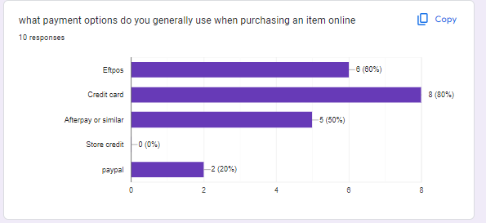

The final question I have added to the survey is titled “do you often leave reviews on items on websites” While this question is like question 2 it gathered far different results as it tells us how often users leave reviews on products in question 2 we determined that 60% of users had left reviews on products while the results from this question determined that only 1 user frequently leaves reviews on products. This helps further determine how useful the reviews feature is to users. Although we gained bad results from this question, this feature is still important to the final design as intel from other questions suggests that this feature is still very useful to customers.

**Part B LO2: Users and their Needs**

**Discuss the different types of system requirements**

**Browsing feature**

The first system requirement the final design will need to implement in is an easy to use browsing system that includes a search located at the top of the page where customers can type in keywords or the name of the item they’re looking for to locate the item. Items will also be sorted into separate categories so you can manually access these categories to look for the item that you want, or you can search for a specific category to find any items that are in that category. Results pages will also include a filtering system where items can be sorted by relevance, popularity, price and age. This allows customers to easily narrow down their search results.

**Layout and design**

The final design for the webstore will also include a simple but functional layout for customers to use. There will be the main navigation bar at the top of the screen with the search, login, contact and trolley features for customers to have quick access to these sections. There will also be an expandable menu on the side of the screen for the more specific features. The front page of the website also needs to be vibrant and have information about current promotions as well as all the top categories.

**Products page**

Each item needs to have a detailed products page that includes multiple pictures of the item so customers can get a good idea of the item they’re purchasing, below that there needs to be a detailed description of the item that includes the book authors details a quick summary of the book and information about its intended purpose. There also needs to be an add to trolley button so customers can fill up their trolley with items and a reviews section so customers can do more research on the item and leave reviews.

**Trolley/checkout system**

The checkout system needs to include an easy to use “trolley” system where customers can add the items, they would like to purchase into the trolley like you would in real life before proceeding to the checkout. Once reaching the checkout customers will be prompted with two options to either login/signup where customers can log into their preexisting accounts with all their delivery information saved to help speed up the process. There also needs to be an option for new customers to purchase items without creating an account. This needs to include a form for customers to fill in with their delivery details. This form should only need the required information for delivery and contact without being too intrusive with the customers' details.

**Payment's page**

After completing the checkout page customers are redirected to the payments page which the project manager has decided will be a hosted payments page which redirects the customers to an external site where they can enter in their credit card details. This will be the only payment option for customers in the final design, but I recommend adding in after pay for the student clientele as they’re in the lower income bracket but still need to purchase books for school.

**Contact page**

Finally, there will be a contact page which needs to be easy for the users to find and have a contact form for users to enter their contact information as well as a detailed msg to the business. This page can be used to specially request items, request a return or for other contact related reasons.

**Discuss the different types of system users as discussed in class.**

**Managers/admins**

The Managers/ administrators are the people who work for GEB and they're the people who use the system for their business. Their requirements are to be able to add new product pages to the website where they can enter all the relevant information. Adjust prices on items on the website due to price increases or reductions or promotions. They essentially need to have access to all parts of the system the make changes to the system.

**Software developers**

Software developers are the people who create the system and need to have full access to the website so they can make changes to the website's layout. Add new features or remove old features.

**Customers**

Customers are the main users of the online system they can be either students, businesses or general customers they purchase items from the store, so they need to have access to the website to browse through all items on the website but have no permissions to alter the website.

**3 different groups of users and their requirements.**

**Regular customers**

Regular customers are people who regularly use the website. They have slightly different requirements to other users. As they regularly use the website, they need to have a good search feature and category feature so they can browse for their required items. They also need a good promotions system as the webstore owner suggested so if they spend over a certain amount per year, they get a discount. They also need a good contacts system and a good log-in system so they can easily check out every time they use the webstore.

**New customers**

New customers have different requirements to regular customers as they are new to the website. They need to have an easy to learn layout with the search and browsing features being in an obvious place as well as having all the current promotions advertised on the front page so they can see them more easily. They also need to have an option at the checkout where they can check out as a guest or sign up to create a new account for next time.

**Business customers**

Business customers have the same requirements as both two previous user groups, but they also require that the accounts system at the checkout allows them to create and verify a business account so they can purchase items through an invoice and pay later. They also need the system to send them out an invoice for the items so they can pay.

**Case Diagram**

[**https://drive.google.com/file/d/1VnNaI9FAgGWnhTC6PbJUZDzqkaVmO0nK/view?usp=sharing**](https://drive.google.com/file/d/1VnNaI9FAgGWnhTC6PbJUZDzqkaVmO0nK/view?usp=sharing)

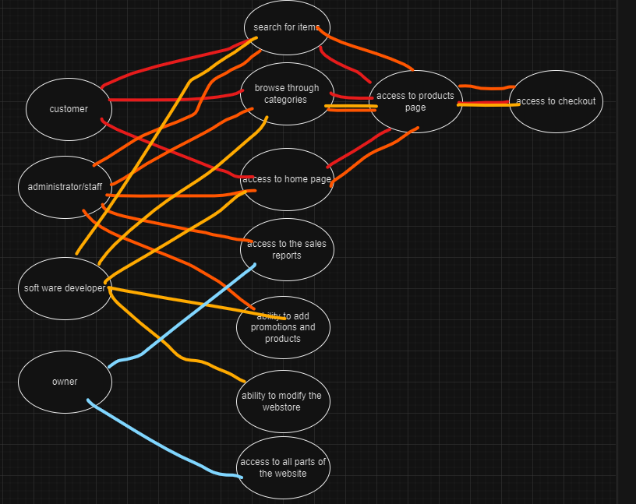

**Business Profile**

**Business Name:** Great Educational books (GEB)

**Business Type**: Online and physical Bookstore

**Mission Statement:**

**Business overview**: GEB is a dedicated physical and online bookstore committed to enriching the academic journey of students and educators alike. Our primary focus revolves around offering an extensive range of meticulously curated educational books. With a passion for knowledge and a deep understanding of the needs of learners and instructors, GEB strives to be the premier source for study materials.

Our mission is to provide students, teachers and the public with valuable educational resources that inspire curiosity and facilitate learning. We understand that education is a cornerstone of personal and professional growth, and we are driven to support this growth by offering a comprehensive selection of study materials.

Whether you're a student seeking textbooks for your courses or an educator searching for teaching aids and supplementary materials, GEB is your trusted partner. We are dedicated to facilitating educational excellence by ensuring access to the right resources, at the right time, and at the right price.

**Key Features:**

**Extensive book selection:** Geb offers an extensive range of educational books and textbooks for students to use as study aids to expand their knowledge, or for teachers to use as teaching aids to help their students excel.

**User Friendly design:** Our Online webstore is designed to be user friendly and provide an enjoyable online experience for all out customers. Users can easily navigate the website to find any items they’re looking for.

**Secure shopping:** We prioritize the security of all our user's data, so we offer safe and secure payment options through a hosted payment page for a secure and hassle-free experience.

**Reviews and ratings:** We offer a reviews feature for all our products so customers can read past reviews of each product and place their own reviews to help future users make decisions on purchasing products.

**Company values:**

**Literary excellence:** It is important to us here at GEB to provide the best possible range of educational books and textbooks to our customers, so we have curated our selection to represent the best in education and knowledge.

**Customer satisfaction:** Customer satisfaction is extremely important to GEB, so we strive to meet all the customers' requirements and are always open to receiving feedback through our contact methods.

**Accessibility: Our** goal is to make all our books accessible to anyone in the country, so we offer an easy-to-use online webstore that’s accessible on any device.

**Location:**

Currently our headquarters is located in Nelson New Zealand, but we offer an online webstore to serve customers across the country and even overseas.

**References**

* Interview #1 Page 21 Brooke Forrester
* Interview #2 page 22 Scott Gillanders
* Chat GPT <https://chat.openai.com> Only used to help understand some of the questions better wasn’t used for any text in this assessment.
* Webstore Owner Transcript pages 3-6
* Project managers decisions pages 6-8
* Mighty apes' website was used on pages 9-12 to identify features of the webstore and 17-19 for the video walkthrough of a website from 2 different perspectives: <https://www.mightyape.co.nz>
* Paper Plus's website was used on pages 13-15 to identify features of the webstore.